# **CTF Challenge: Network Scanning - Using GreyNoise**



# **1. Introduction**

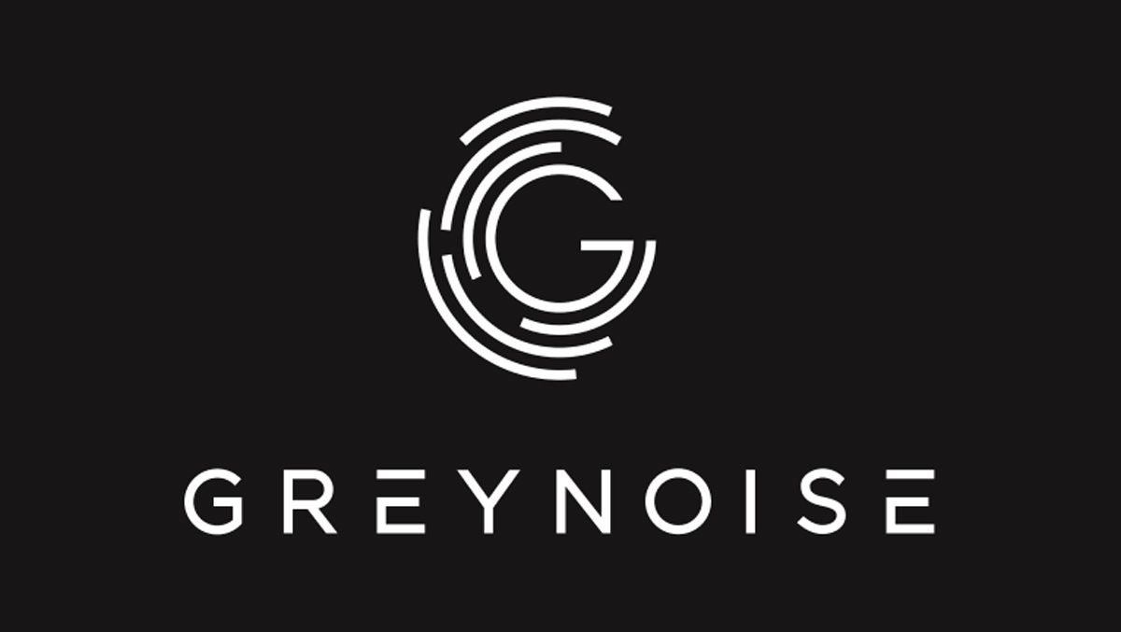

GreyNoise collects and analyzes internet-wide scan and attack traffic to help you understand and respond to internet threats. This challenge will introduce you to GreyNoise to gather information about a specific IP address.

# **2. Tools and Requirements**

* Access to the internet and GreyNoise

# **3. Scenario**

Suppose, You are an ethical hacker tasked with gathering information about a specific IP address using GreyNoise. Your job is to determine the IP address details.

# **4. Process to follow while performing CTF**

Step 1: Visit GreyNoise: [**https://www.greynoise.io/**](https://www.greynoise.io/) and click on search for free option.

Step 2: IP Lookup: Enter the IP address **76.76.21.21** in the search bar and start the search.

Step 3: Solve the CTF.

# **5. Let’s Begin the Challenge**

**Question**

**Flag 1: When was this first IP seen?**

*Answer: 2021-05-15*

**Flag 2: What is the location of the IP Address?**

*Answer: United States*

**Hint**

**Flag 3: What is the Autonomous system Number(ASN) of the Targeted IP address?**

*Answer:AS16509*

**Hint:**

Use the "IP Lookup" tool on GreyNoise to perform the analysis.



